PCGamingSketch
Created on 10/9/2010
Table of Contents
SketchFlow Map 2
Navigation Screens 2
Start 3
Detail Page 4
Internal Page 5
GoToInternal 6
MouseWheel 7
MouseWheelVS 8
Reset 9
Refined 10
GoToInternal 11
Version 1 12
Version 2 13
Open 14
Close 15
Version 3 16
Revision: 0 16
Local Files 16
Feedback from Unknown User - 11:27 PM 10/3/2010 16
Version Approved 18
Figures
Figure 1: SketchFlow Map 1
Figure 2: Start 2
Figure 3: Detail Page 3
Figure 4: Internal Page 4
Figure 5: Internal Page, GoToInternal 5
Figure 6: MouseWheel 6
Figure 7: MouseWheel, MouseWheelVS 7
Figure 8: MouseWheel, Reset 8
Figure 9: Refined 9
Figure 10: Refined, GoToInternal 10
Figure 11: Version 1 11
Figure 12: Version 2 12
Figure 13: Version 2, Open 13
Figure 14: Version 2, Close 14
Figure 15: Version 3 15
Figure 16: Ink feedback from Unknown User 16
Figure 17: Version Approved 17

SketchFlow Map
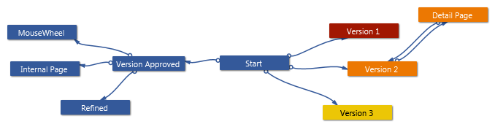
Figure 1: SketchFlow Map

Navigation Screens

Start

Figure 2: Start

Detail Page
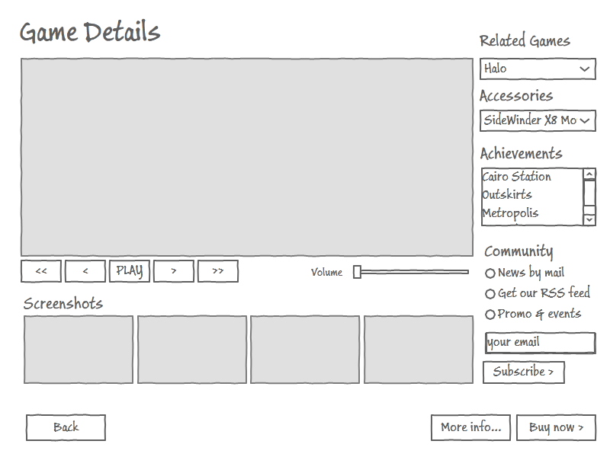
Figure 3: Detail Page

Internal Page
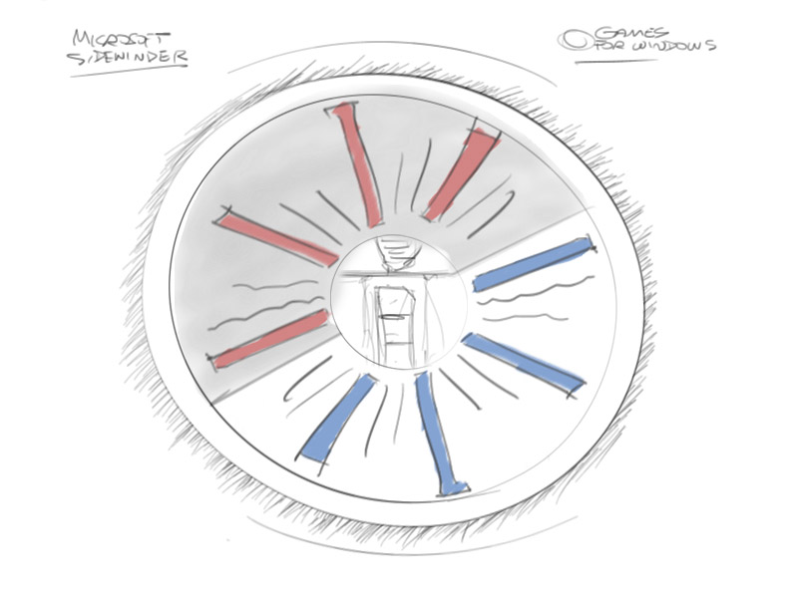
Figure 4: Internal Page

GoToInternal
Figure 5: Internal Page, GoToInternal

MouseWheel
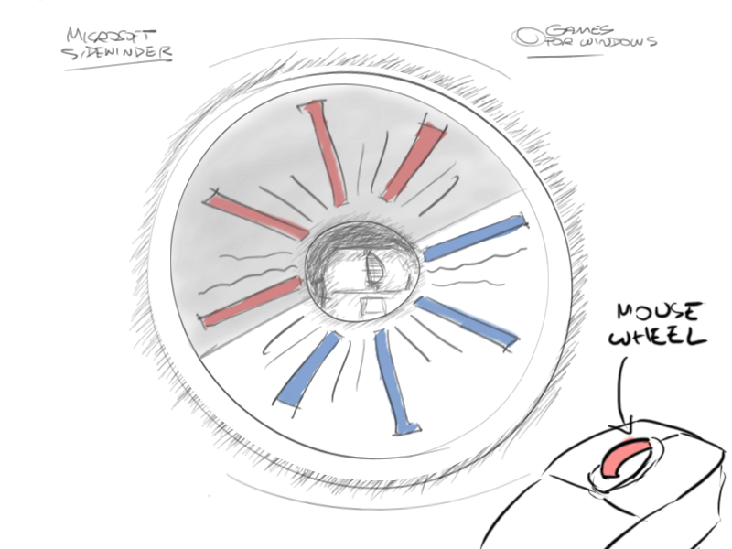
Figure 6: MouseWheel

MouseWheelVS
Figure 7: MouseWheel, MouseWheelVS

Reset
Figure 8: MouseWheel, Reset

Refined
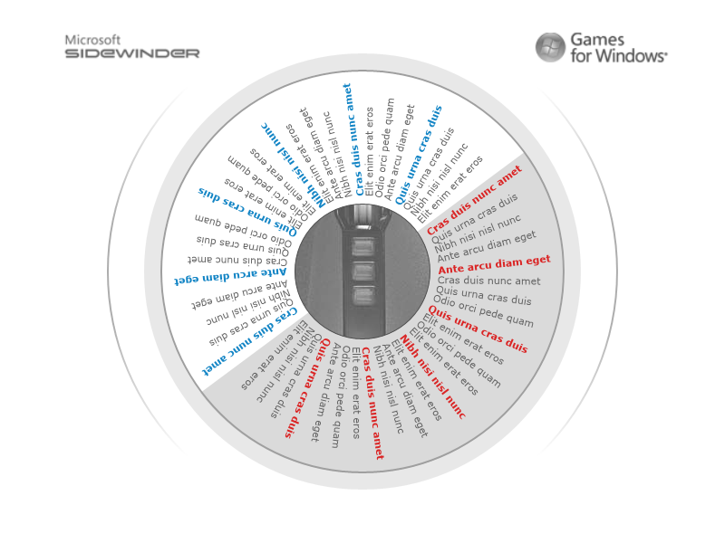
Figure 9: Refined

GoToInternal
Figure 10: Refined, GoToInternal

Version 1
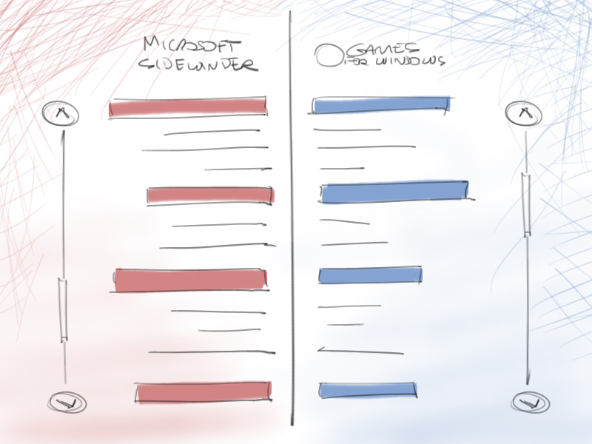
Figure 11: Version 1

Version 2
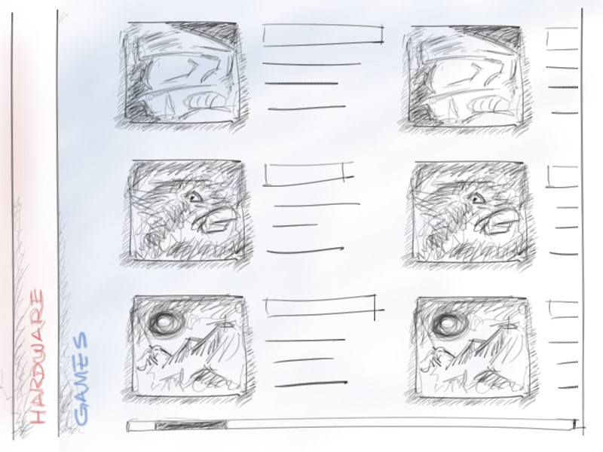
Figure 12: Version 2

Open
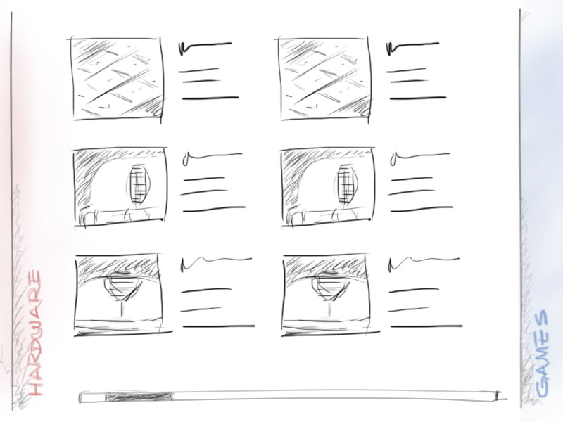
Figure 13: Version 2, Open

Close
Figure 14: Version 2, Close

Version 3
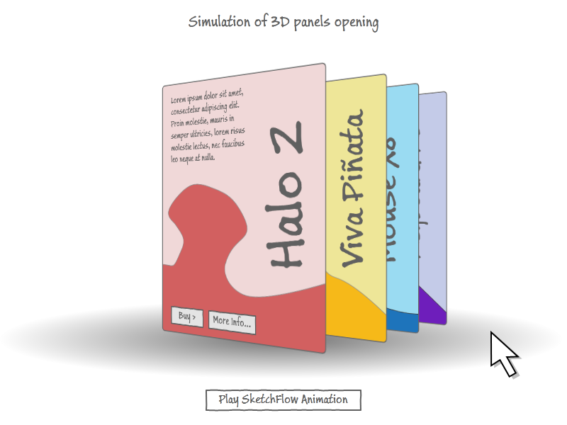
Figure 15: Version 3

Revision: 0

Local Files

Feedback from Unknown User - 11:27 PM 10/3/2010
C:\Users\ManuAndrew\Documents\Expression\Blend 4\Samples\PCGamingSketch\PCGamingSketch\PCGamingSketchScreens\Feedback Files\MyFeedback.feedback
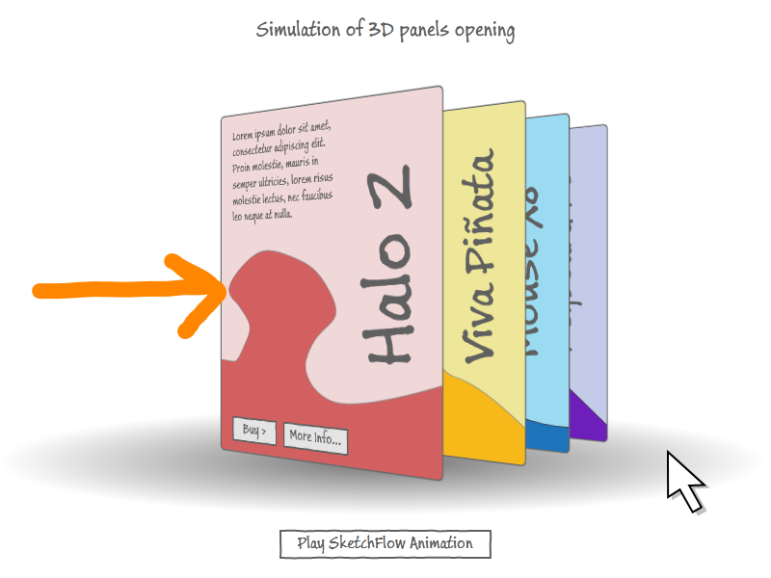
Figure 16: Ink feedback from Unknown User
FYI, Halo 2 was OK, but Halo Reach is so much better.
Will the More Info button launch a new web browser? Or will it show a new part of this page?
Are we still doing lunch next week to talk about the final layout????
Type your feedback here

Version Approved
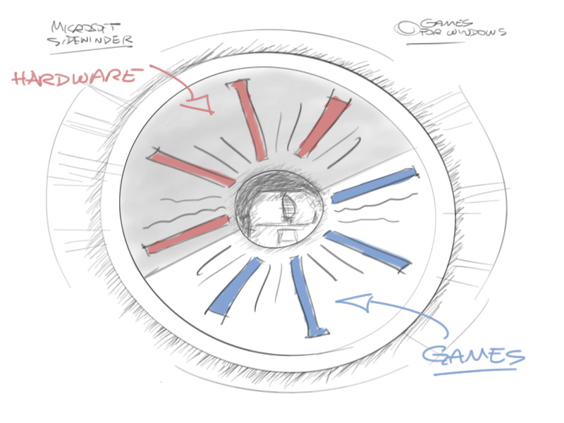
Figure 17: Version Approved

